Day 5 hackathon

**Implementation Report**

**SETP:1**

SOBIA RAO

**Dynamic Routing:** A networking method where routers automatically update paths based on real-time network conditions using protocols like OSPF, BGP, and RIP.

ADDTOCART PAGE



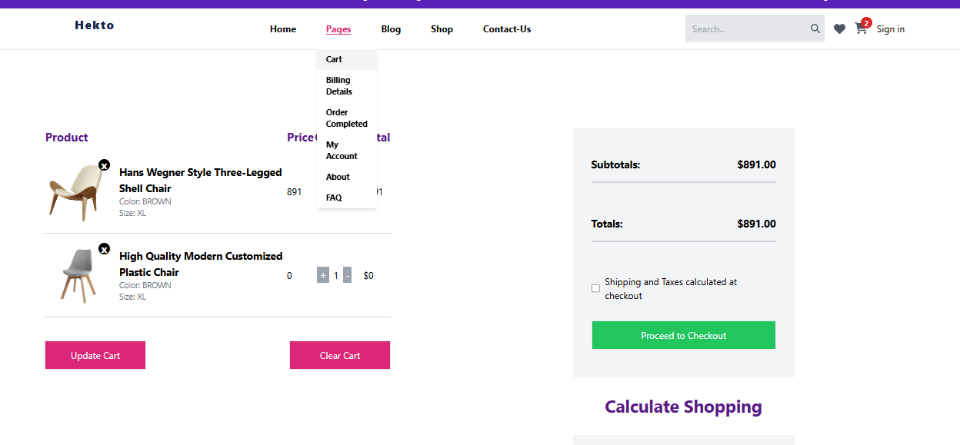

ADD PRODUCT ADDTOCART

SOBIA RAO



JJJJJJJJJJHKJHKJHKJHJKH

AD

 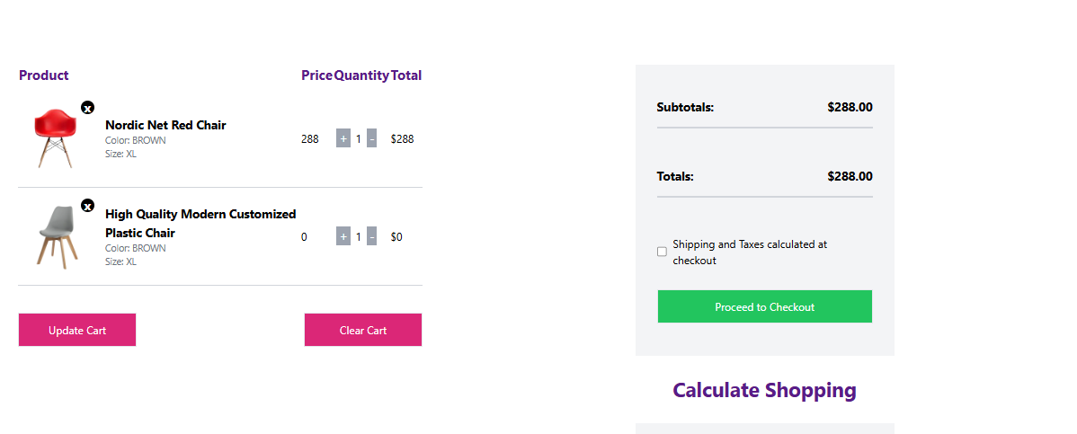**CHEAK OUT PROCESS** SOBIA RAO

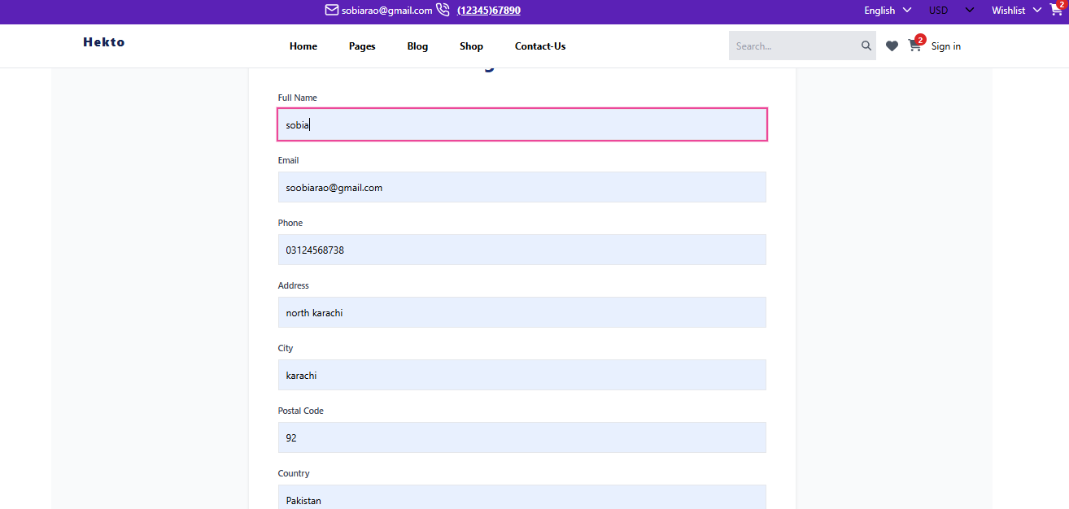 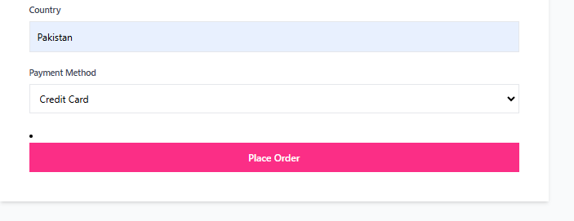 P

Order completed 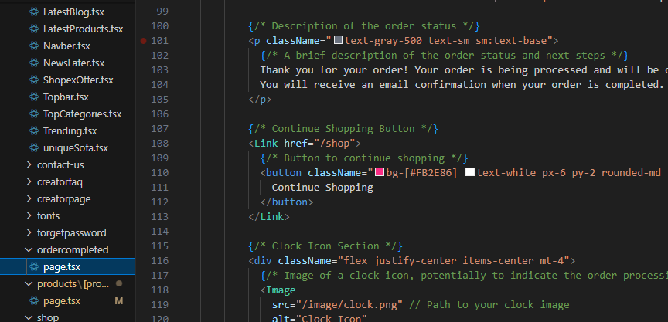

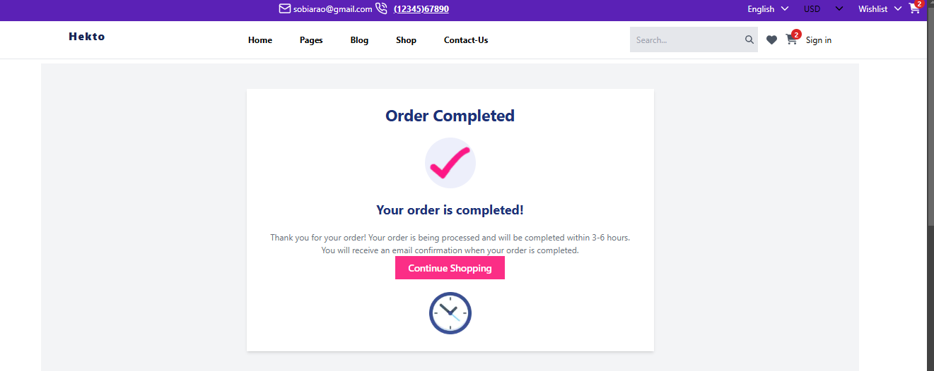 login button page

SOBIA RAO

hhkkkkkkkk

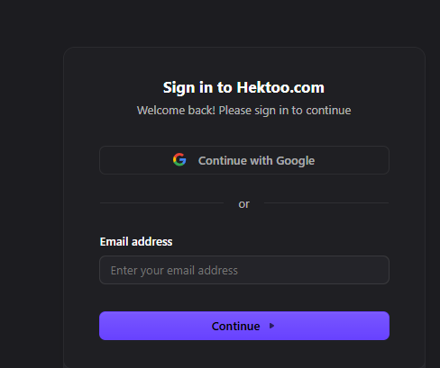

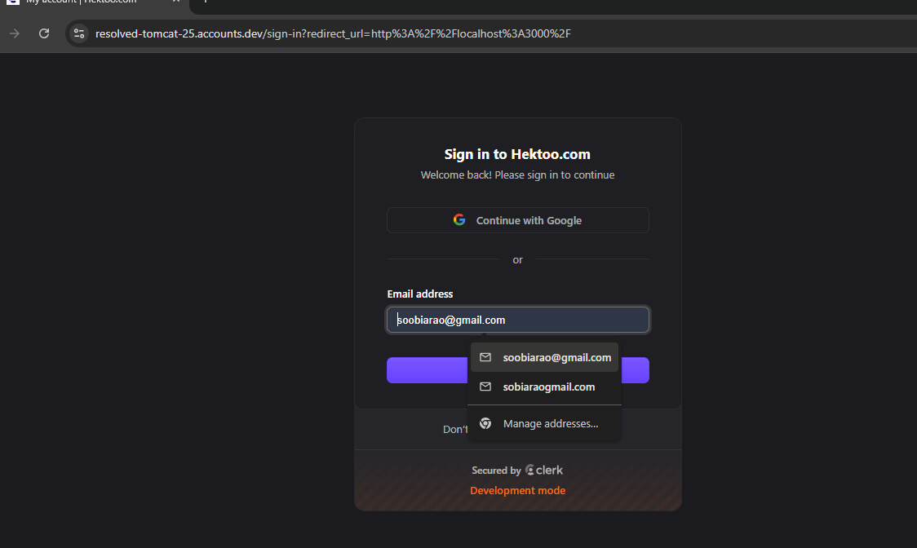

sing up

SOBIA RAO

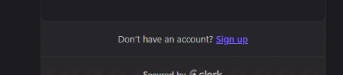

Wrong password error show

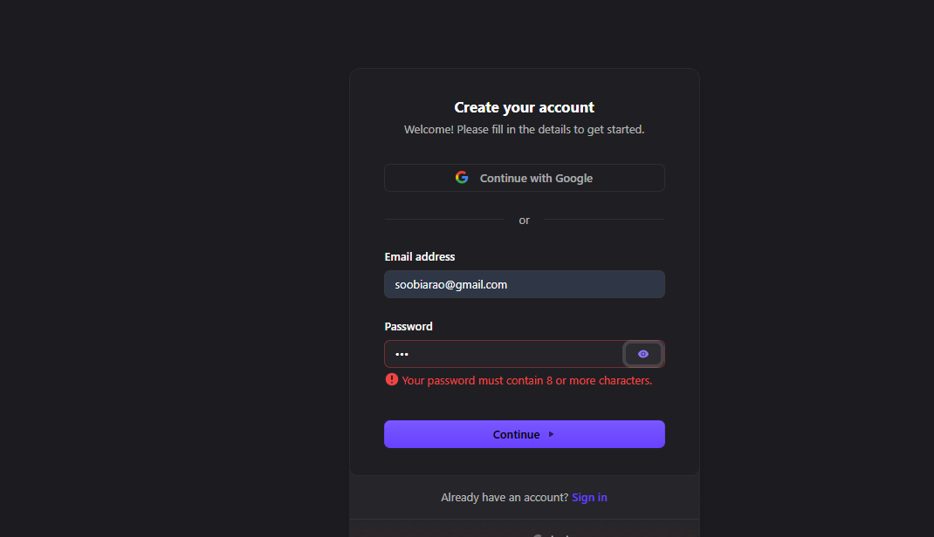

successfully password show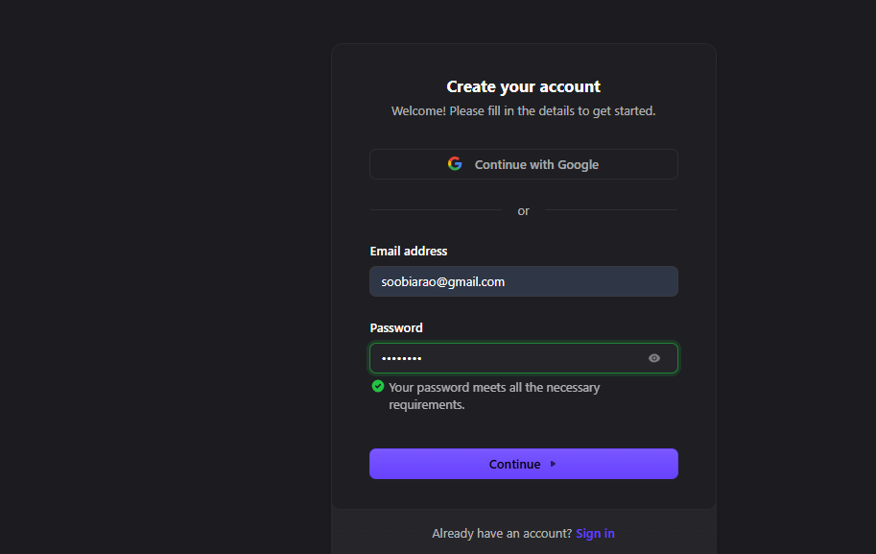successful created sign-up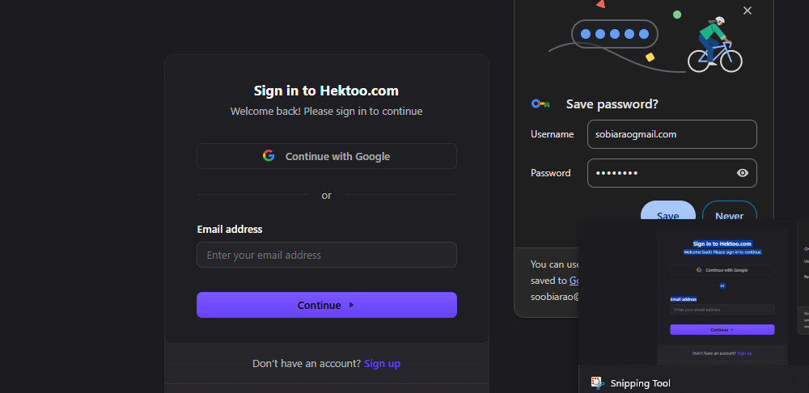

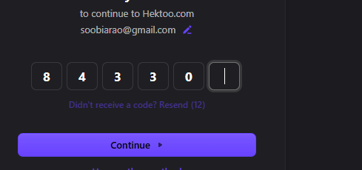

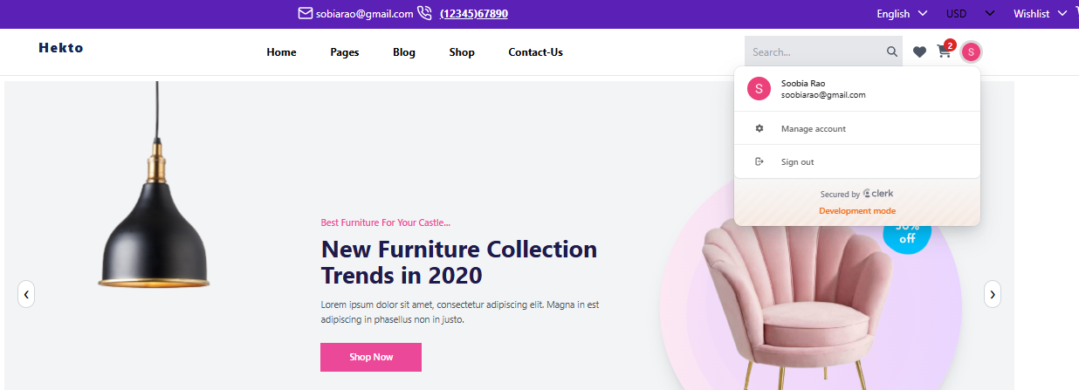

billing information

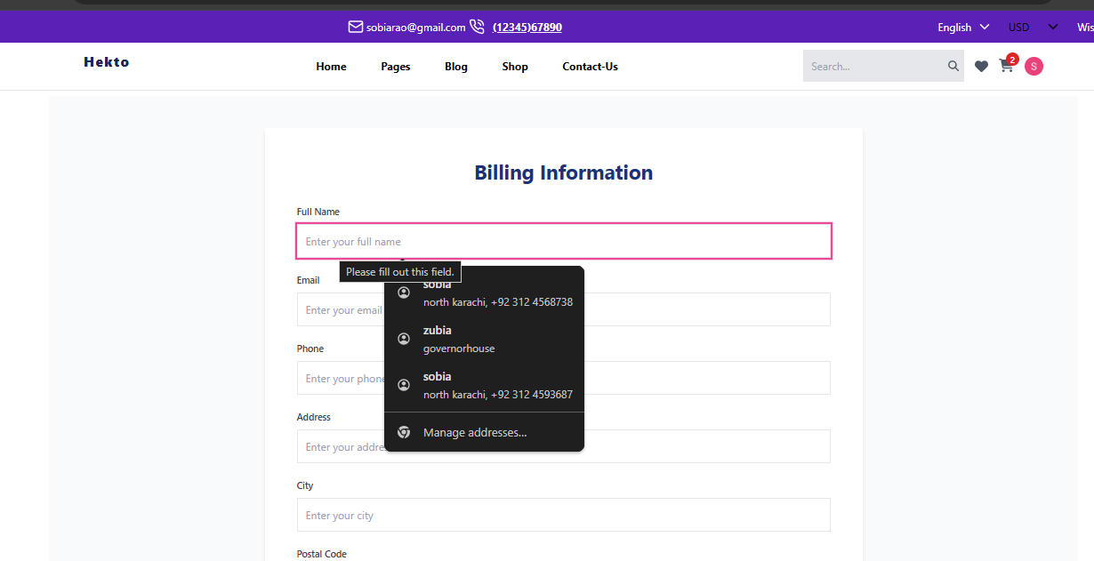

Mobile /tablets responses

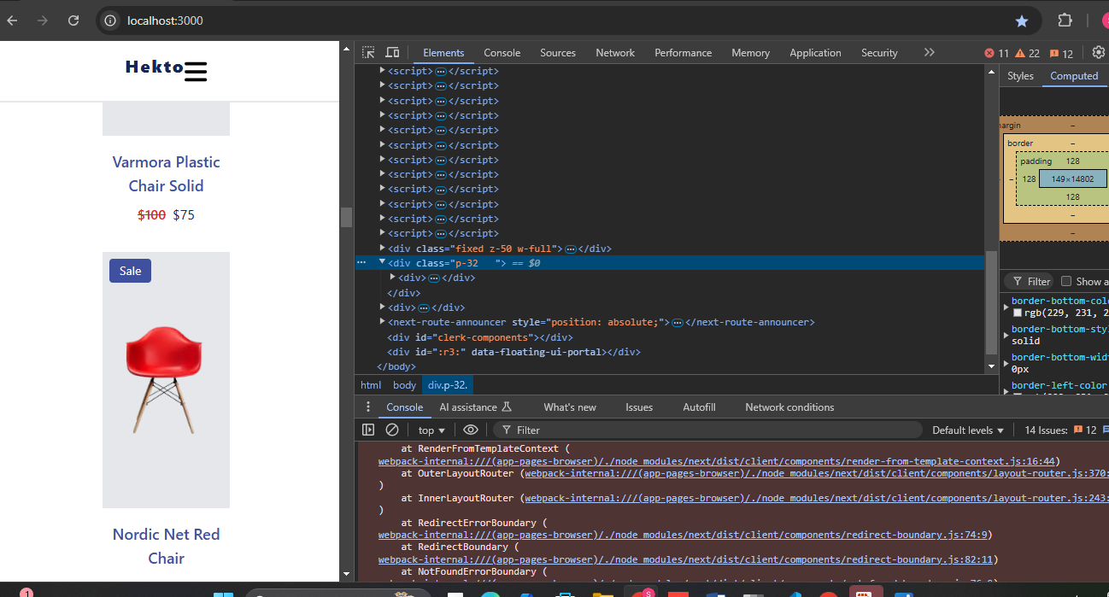

Tablets responces

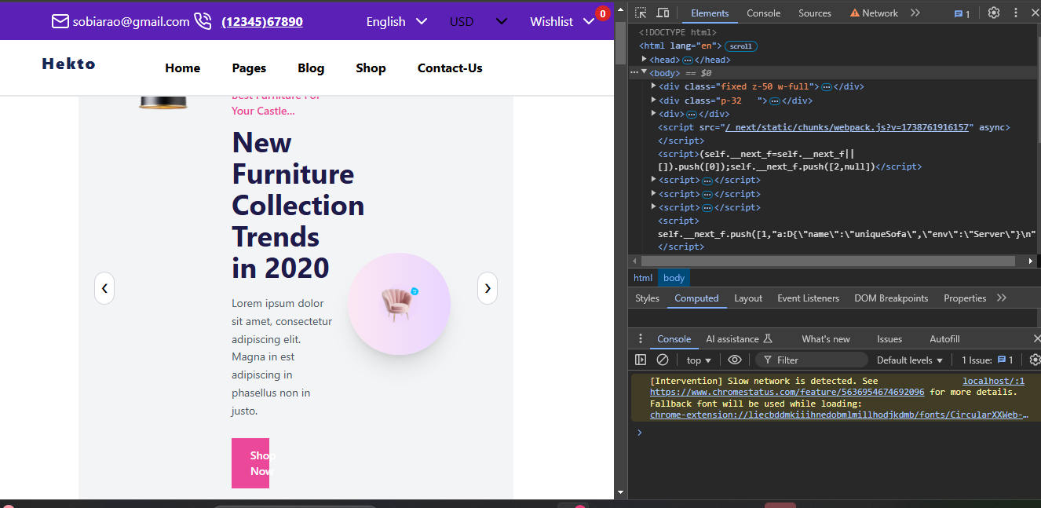

Not api working 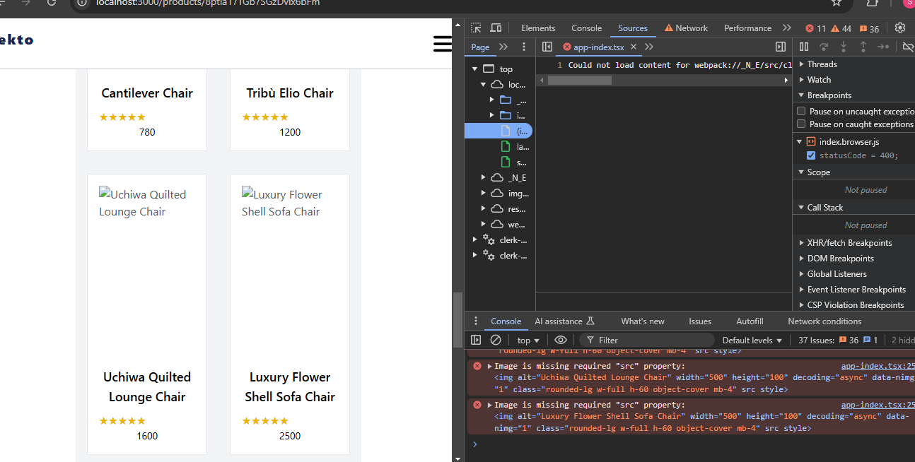

Api check status thunder client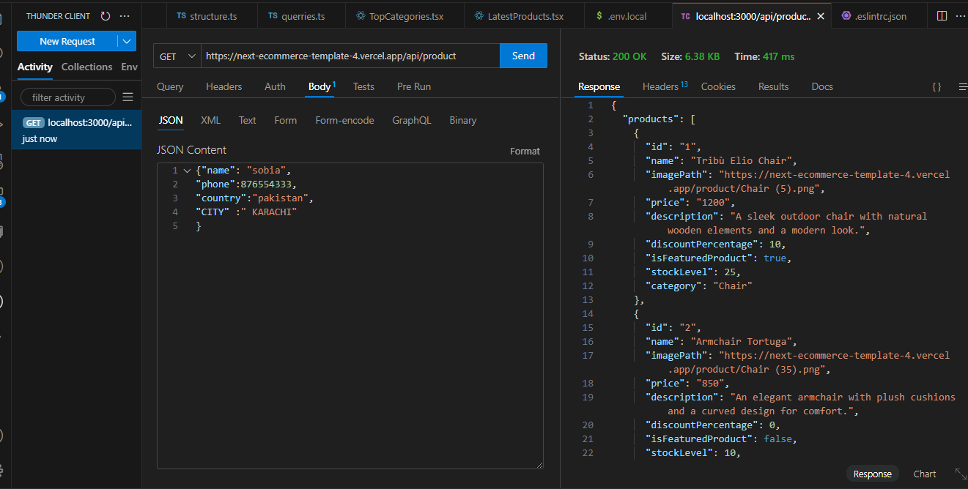

The image contains a **test case report** with five test cases, each detailing a functionality test for a system. Here's a **summary** of the key points:

1. **TC001 - Product Listing Page:** Verified that products are displayed correctly. ✅ **Passed** (Low severity).
2. **TC002 - API Error Handling:** Ensured error messages appear when the API is disconnected. ✅ **Passed** (Medium severity).
3. **TC003 - Cart Functionality:** Checked if the cart updates correctly when a product is added. ✅ **Passed** (High severity).
4. **TC004 - Mobile Responsiveness:** Tested if the layout adjusts on different screen sizes. ✅ **Passed** (Medium severity).
5. **TC005 - Login/Signup Page:** Verified project addition and page display. ✅ **Passed** (High severity).

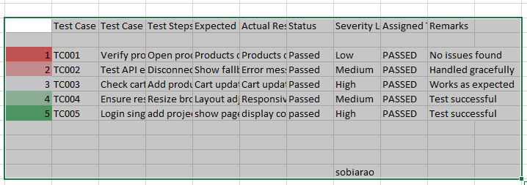

Light house testing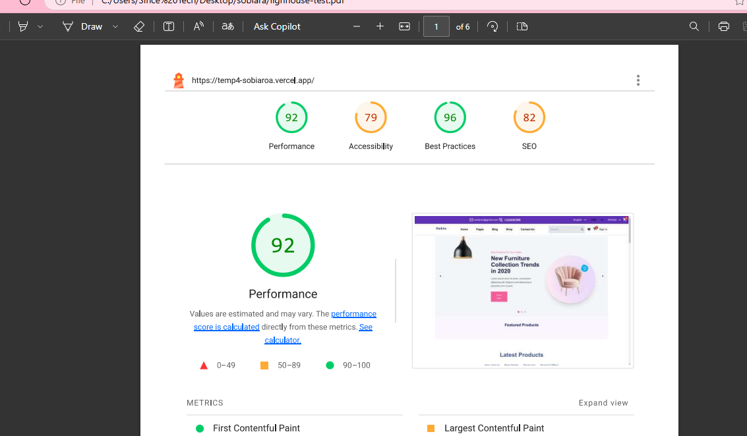

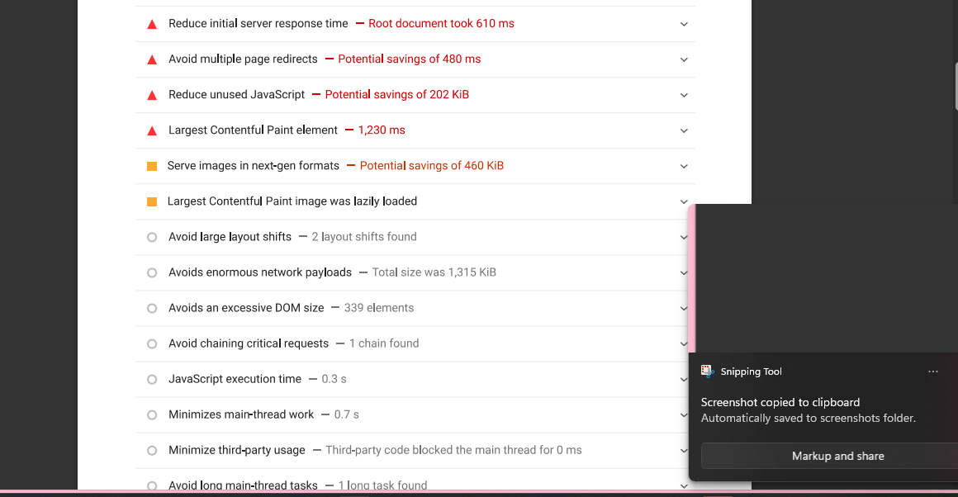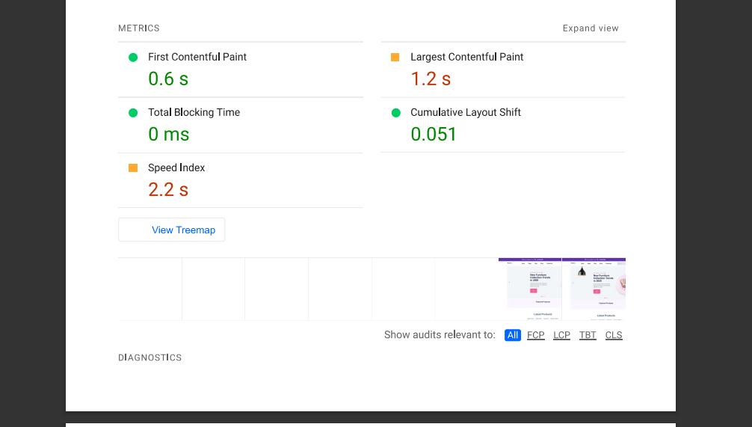 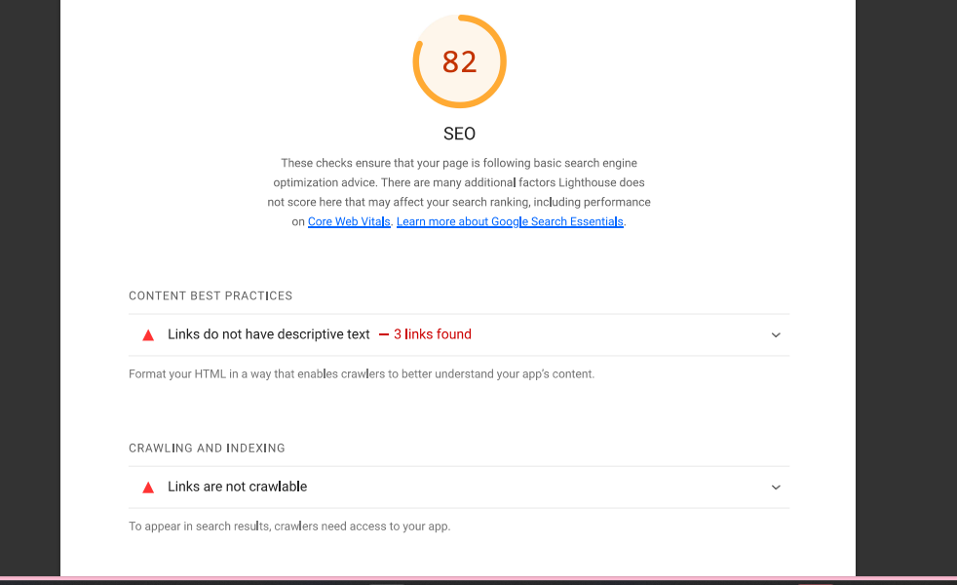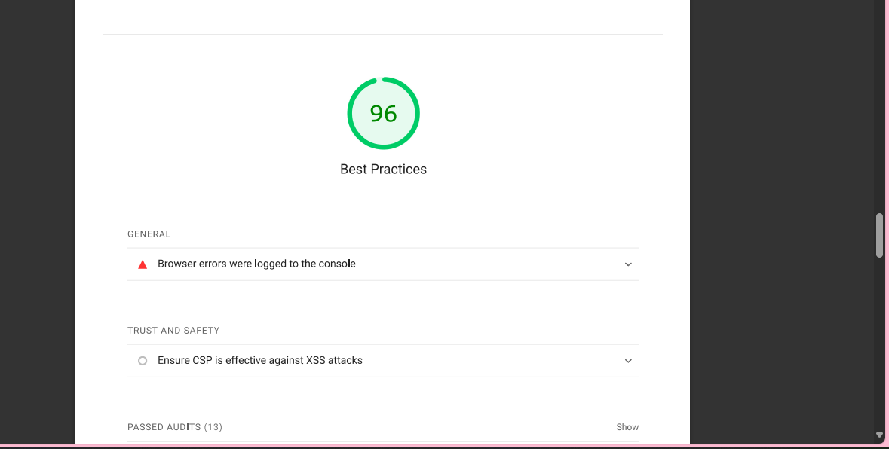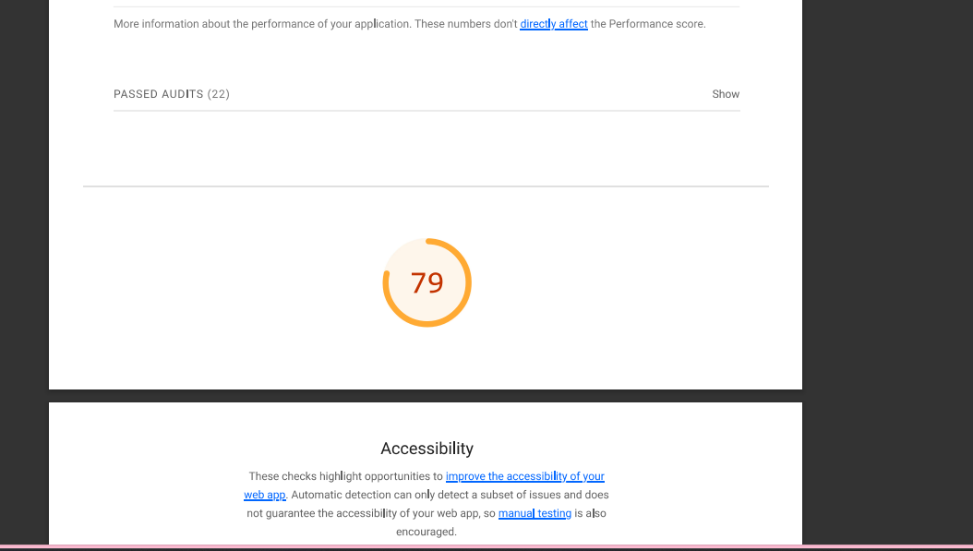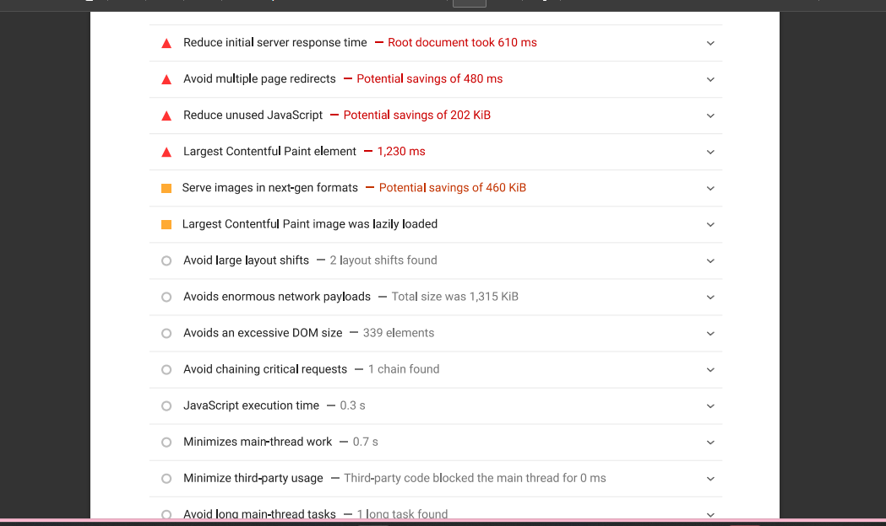

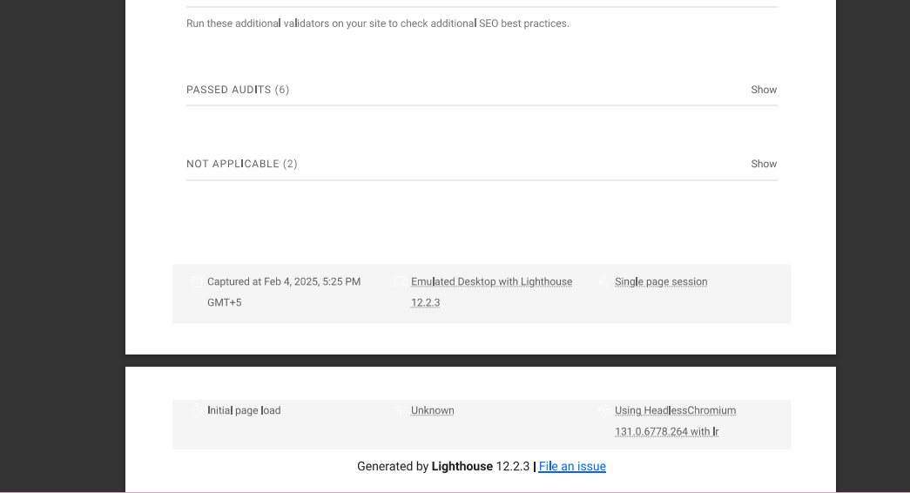

Developer resources..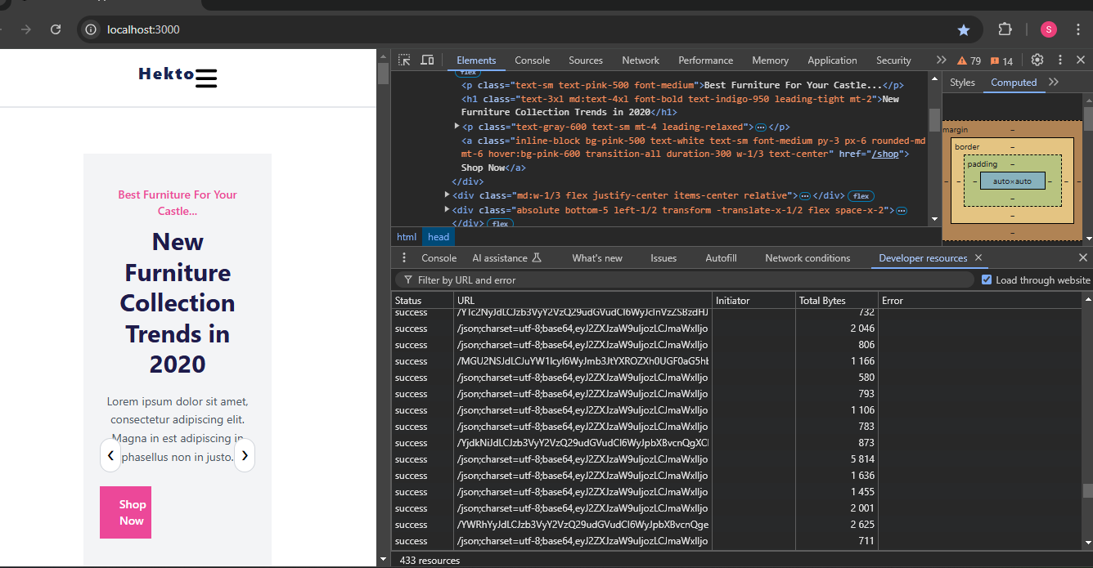

Performance monitor..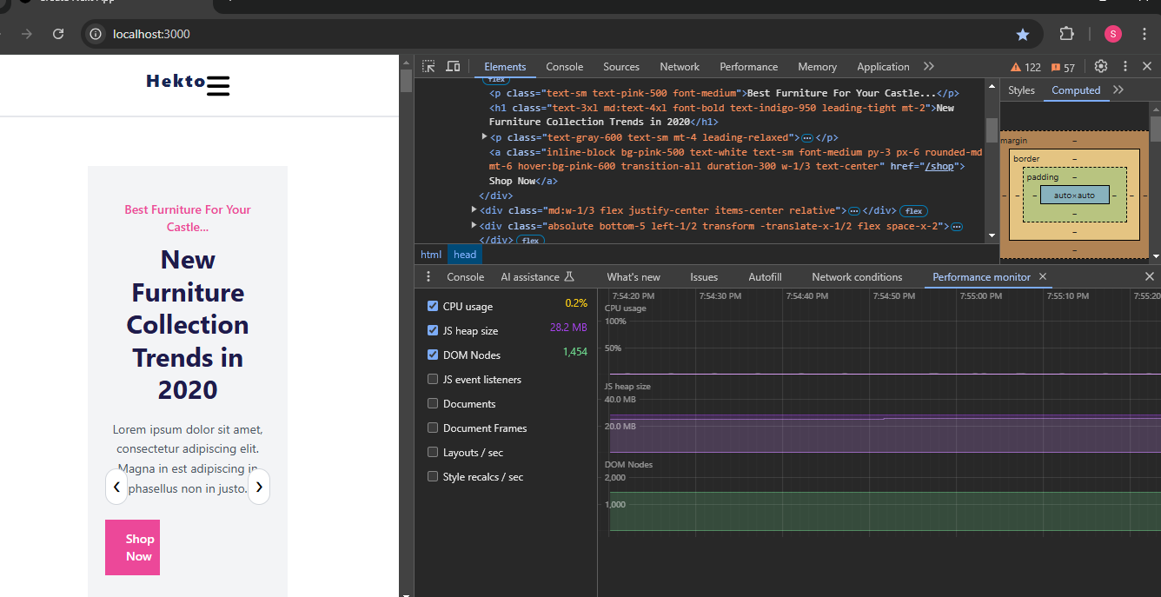

Security testing

sobiarao